Deliverable 4: Wireframes & Feature Plan
CSC425 Fall 2025
Student Name: Mark Sharovarov
Date Submitted: September 21, 2025
GitHub REPO URL: https://github.com/MUS1C17/CSC425Team3
Branch Name: MarkSharovarov-Delivarable4

1) Low-Fidelity Wireframes (Mobile-First)
Insert the images below into the corresponding spots in the template:
- Login Screen
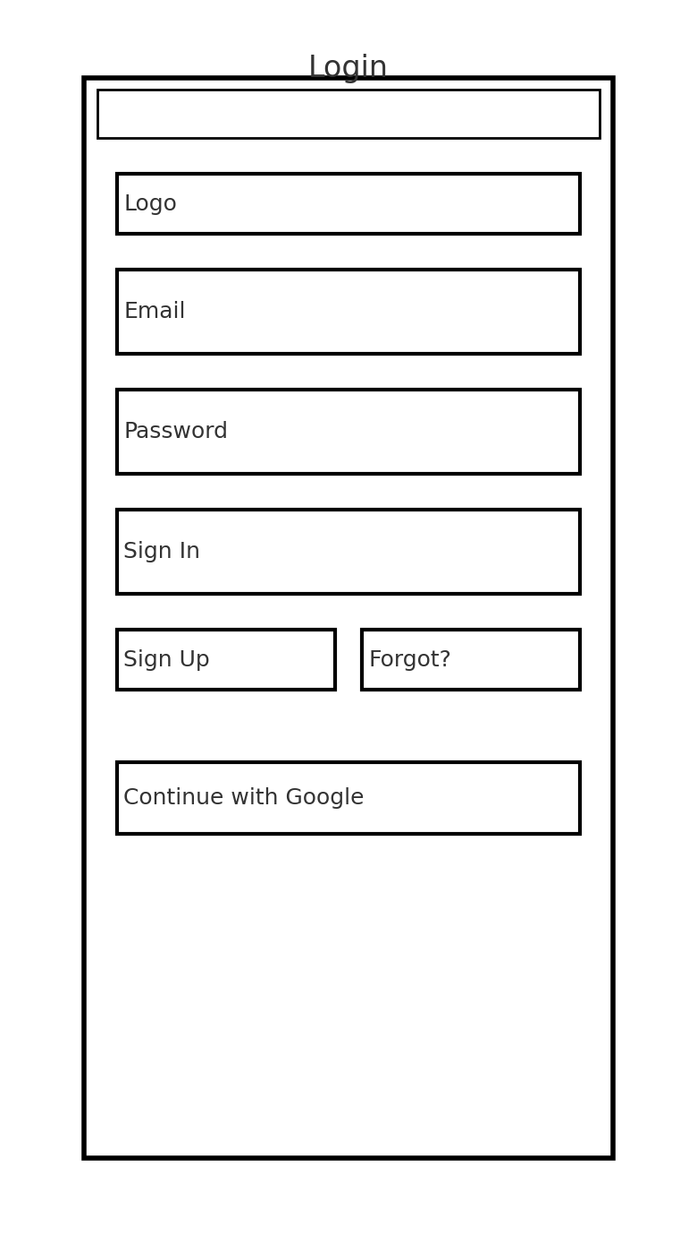
- Dashboard Screen
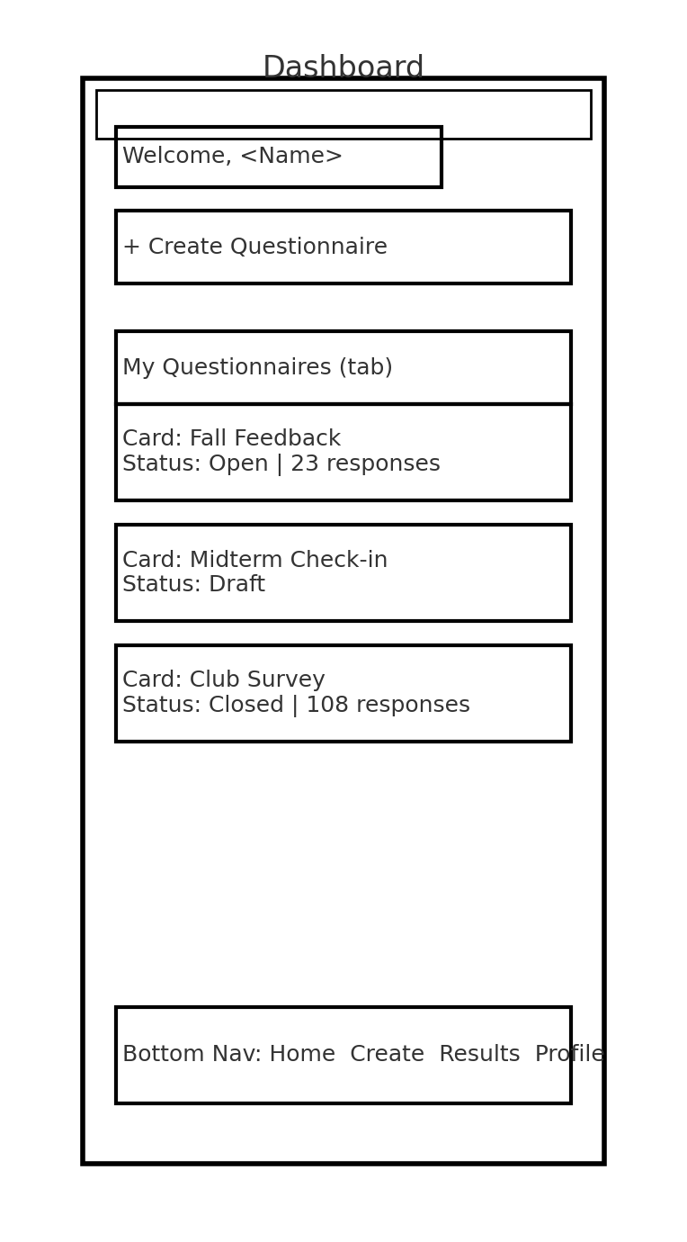
- Create Questionnaire Screen
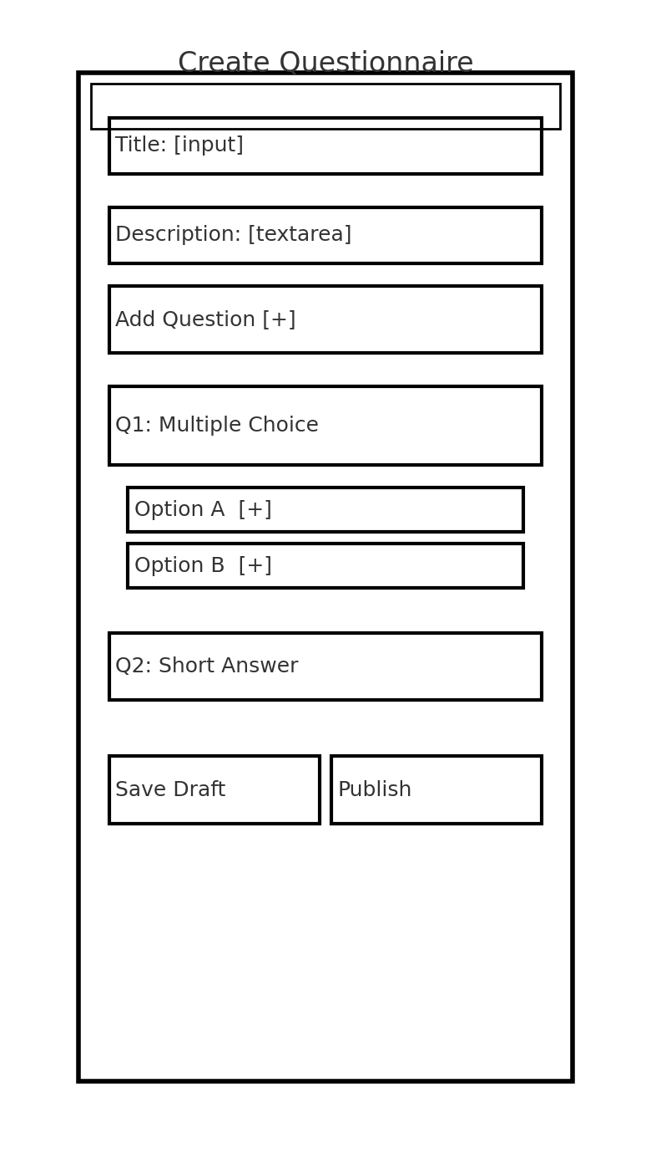
- Take Questionnaire (Respondent) Screen
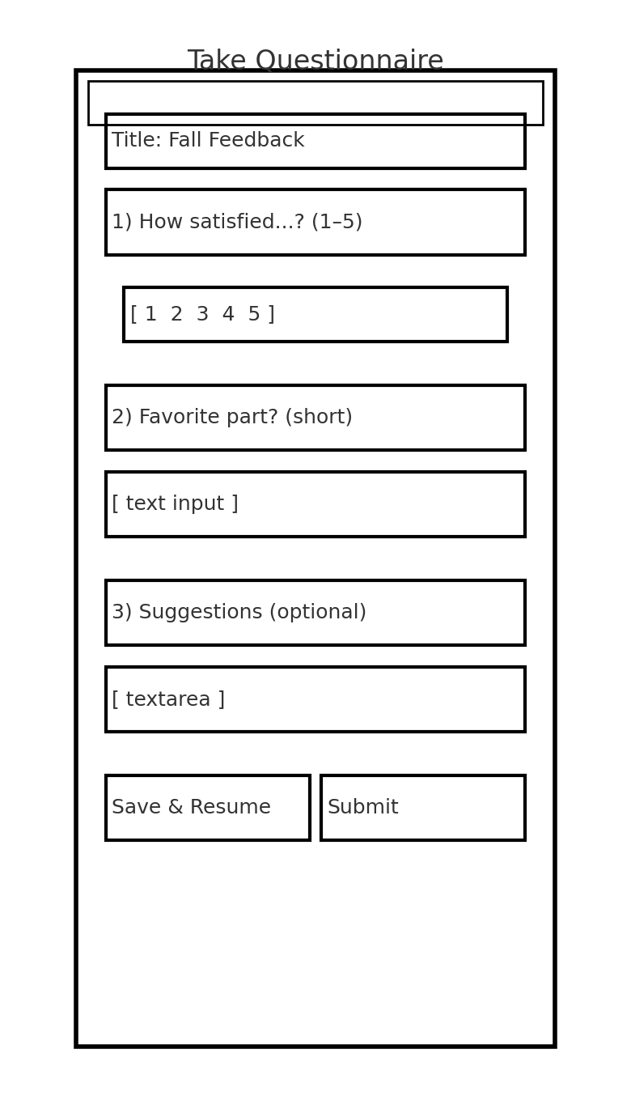
- Results/Analytics Screen
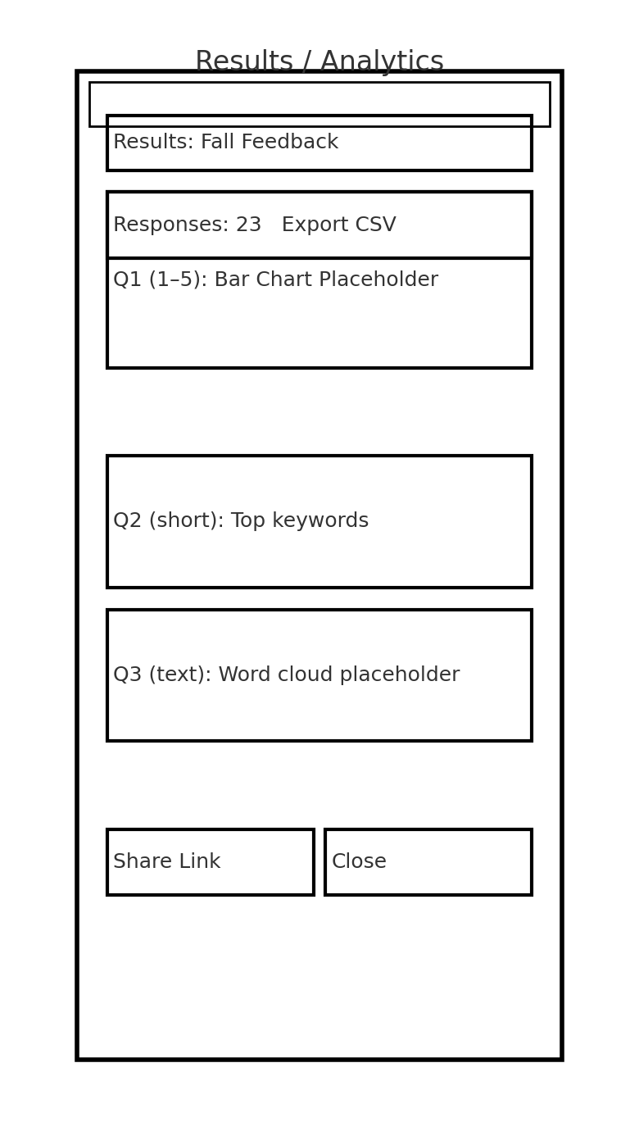
These are intentionally simple, black-line, mobile-first sketches that show structure (headers, key buttons, inputs, bottom-nav) without styling.

2) Functional Requirements
- Authentication
  - Sign up, login, logout
  - Password reset and optional social login (Google)
  - Session management; protected routes (Dashboard, Create, Results)
- Questionnaire Management (Creators)
  - Create, read, update, delete questionnaires
  - Add, edit, reorder, delete questions (MCQ, Likert 1–5, short/long text, optional/required)
  - Draft vs Published states; Save as draft
  - Share via public URL/QR; optional access code
- Response Collection (Respondents)
  - Submit answers on mobile
  - Save & resume (link-based token)
  - Client-side validation and helpful error messages
- Results & Analytics
  - View response counts, completion rate
  - Auto charts for MCQ/Likert; keyword summary for short text
  - Export CSV (responses + metadata)
- Navigation
  - Mobile-first bottom navigation (Home/Dashboard, Create, Results, Profile)
  - Deep-linking from share URL to active questionnaire
- Data & Storage
  - Backend persistence (e.g., Supabase/Postgres)
  - Schema for Users, Questionnaires, Questions, Options, Responses, Answers
  - Soft-delete for safety; timestamps for auditing
- Security & Access
  - RLS/ACL so creators can only manage their own content
  - Basic rate-limiting on submissions
  - CAPTCHA or lightweight bot-protection on public forms
- Quality & UX
  - Input validation (required, min/max choices, text length)
  - Empty states, loading states, toasts
  - Error boundaries & graceful failure
- Non-Functional
  - Performance: load questionnaires < 2s on average campus Wi-Fi
  - Accessibility: semantic HTML, labels, keyboard navigation, color-contrast
  - Testing: unit tests for core logic; basic e2e for create→publish→respond→export

3) User Stories
- As a creator, I want to log in securely, so that I can access and manage my questionnaires.
- As a creator, I want to add multiple types of questions (MCQ, Likert, short text), so that I can gather the right kind of feedback from participants.
- As a creator, I want to publish a questionnaire and share a link/QR code, so that respondents can easily fill it out on their phones.
- As a respondent, I want to save my progress and return later, so that I can complete longer questionnaires without losing my work.
- As a creator, I want to view simple analytics and export a CSV, so that I can summarize results and include them in my report.
(Optional extra)
6. As a creator, I want to protect a questionnaire with an access code, so that only my intended audience can respond.

4) User Journey Flow
Option A (Diagram): Insert this image into the template – Download Flow Diagram
Option B (Written Description):
- User opens the app → sees Login (or Sign Up).
- On successful auth → redirected to Dashboard with a list of questionnaires and a Create CTA.
- User taps Create Questionnaire → fills Title/Description, adds questions, saves draft, then Publishes.
- App generates a Share Link/QR → user distributes to respondents.
- Respondent opens link on mobile → completes questions with validation → Submit (or Save & Resume).
- Creator returns to Results → views charts and keyword summaries → Export CSV if needed.
- User Logs out; session ends.

5) Document Layout Professional
- This planning package is organized to be developer-ready: clear, scoped features; mobile-first wireframes; concrete data-flow; and user stories that map directly to tasks.

